# What is Docker and what is it used for?

Docker is a virtual environment used to run programs.

Docker vs Virtual Machine

|  |  |  |
| --- | --- | --- |
| Criteria | Virtual Machine | Docker |
| OS Support | Occupies a lot of memory space | Docker Containers occupy less space |
| Boot-up time | Long boot-up time | Short boot-up time |
| Performance | Running multiple virtual machines leads to unstable performance | Containers have a better performance as they are hosted in a single Docker engine |
| Scaling | Difficult to scale up | Easy to scale up |
| Efficiency | Low efficiency | High efficiency |
| Portability | Compatibility issues while porting across different platforms | Easily portable across different platforms |
| Space allocation | Data volumes cannot be shared | Data volumes can be shared and reused among multiple containers |

## What is DevOps and its tools

DevOps is a collaboration between development and operation teams which enables continuous delivery of applications and services to our end users.

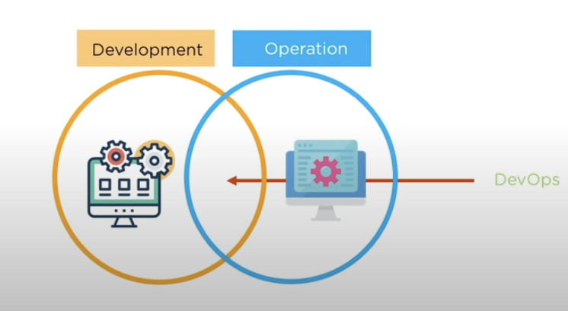

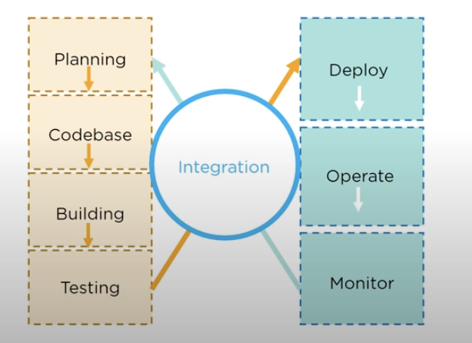

For planning and Codebase we use tools like Jira & Git.

For Building we use Maven and Gradle

Testing Selenium

Deploy and operation Docker & Chef

Monitor -> Nagios

## What is Docker?

Docker is a tool which is used to automate the deployment of applications in lightweight containers so that applications can work efficiently in different environments.

Container is a software package that consists of all the dependencies required to run an application.

* Multiple applications can run on same hardware.
* Maintains isolated applications
* High productivity
* Quick and easy configuration

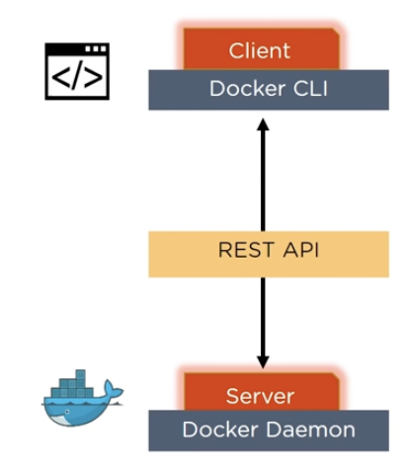

Docker Engine is the base engine installed on host machine to build and run containers using Docker components and services.

It uses a client-server architecture

Docker Client and Server communicate using Rest API.

Docker is a service which runs a command, which is translated using REST API and is sent to the Docker Daemon (server).

Then the server checks the client request and interacts with the operating system in order to create or manage containers.

## Components of Docker

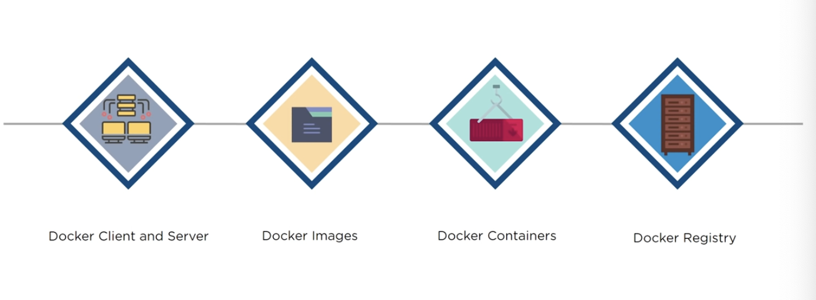

Docker is accessed from the terminal and a Docker host runs the Docker Daemon and registry.

A user can build Docker Images and run docker Containers by passing commands from the Docker Client to Docker server.

Docker Image is a template with instructions, which i sused for creating Docker containers

A Docker image is built using a file called Docker File.

Docker Image is stored in a Docker Hub or repository.

Obrázok, na ktorom je text

Automaticky generovaný popis

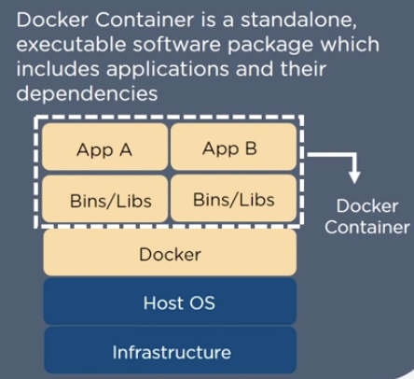

Docker Container is a standalone,executable software package which includes applications and their dependencies.

Numerous Docker Containers run on the same infrastructure and share operating system with its other containers.

Each application runs in isolation.

Docker Registry is an open source server-side service used for hosting and distributing images.

Docker also has its own default registry called Docker Hub.

Images can be stored either in public or private repositories

Public repositories can be used to host Docker Images which can be used by everyone.

Private repositories allows a user to store Docker Images that he/she wants to keep private.

Pull and Push are the commands used by users in order to interact with a Docker Registry.

In order to build a container , pull command i used to get a Docker image from the Docker repository.



With push command , a user can store the Docker Image in Docker Registry.



